**Simple HTML/CSS Challenge**

Task One:  
Write a HTML layout which has three columns which stretch 100% of the height of the browser, where the left and right column are 200px wide and the center column fills 100% of the leftover width.

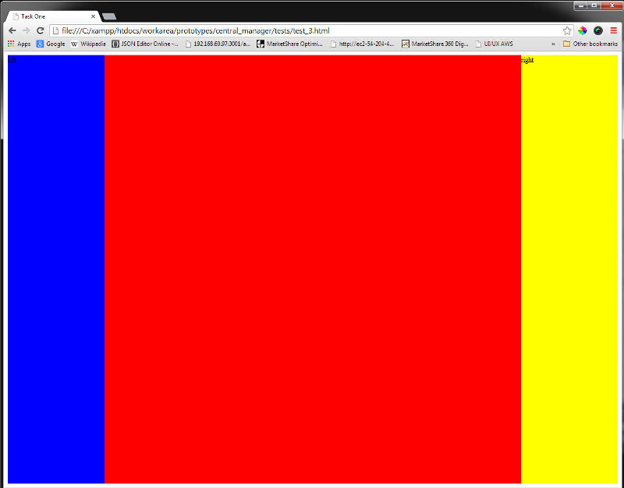

Task Two:  
Write a HTML layout which has three nested div's which are all different widths and heights but are all horizontally and vertically centered within each other and then centered vertically and horizontally within the body.

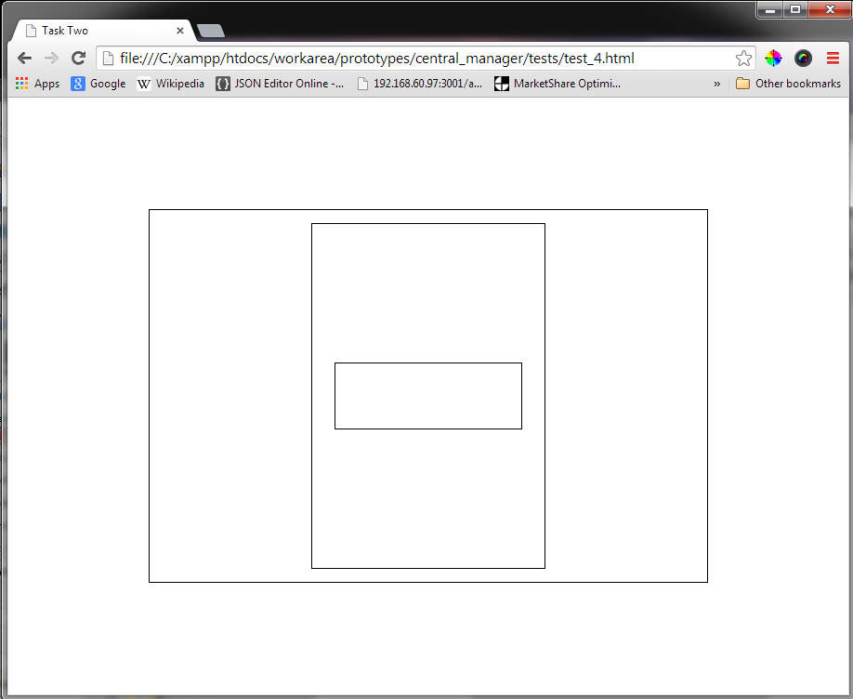

**Simple Javascript Challenge**

Task Three:  
Write a function that searches array "list" to find the object with the lowest "e" value and return that object's "i“ value.

var list = [{i:’cat’, e:9}, {i:’dog’, e:4}, {i:’fish’, e:2},{i:’snake’, e:12},{i:’rabbit’, e:12}];

Task Four:  
Write a function that will correctly identify object types:

identify (""); // returns "string"

identify ({}); // returns "object"

identify ([]); // returns "array"

identify (new Date()); // returns “date"